Finalist Application for *Mark A. Sternheimer Capstone Design Award*

2017

Computer Science 317:

Campus Bluetooth Tag Network

Team Members:

Nicholas Bennett, Computer Science - _________________________

Jordan Mays-Rowland, Computer Science - _________________________

Justin Yirka, Computer Science - _________________________

Faculty Advisor:

Eyuphan Bulut, Ph.D., Dept. of Computer Science - _________________________

Date: ____________

As described in our Proof of Concept Proposal, this project seeks to implement a network of phones and low-cost Bluetooth tags to assist members of the campus community to locate lost items. Users will be supplied with Bluetooth Low Energy (BLE) tags which they can attach to their possessions. Using an iOS or Android app, a user’s phone will begin passively monitoring their tags, recording the last known GPS locations of their items. If the user loses a tagged item, they may use their phone to recall the last known location. Further, using a *crowdGPS* model, the user will be notified if any other device in the network observes the location of their lost item.

These features are similar to existing closed-source products such as *Tile* and *TrackR.* We improve upon these alternatives by implementing security considerations to-date ignored by other tag networks. Research has suggested the importance of a decentralized model with an untrusted server, implementing cryptographic schemes which protect both user anonymity and security [1]. This project will apply these proposals in a practical manner, ensuring the privacy of users’ location data from all parties, including governments and hackers (see Appendix).

This project will also improve upon current products by implementing fixed-location Bluetooth scanners throughout campus. Systems which depend on GPS location suffer indoors due to reduced signal accuracy. Our system will include fixed receivers which will report precise locations, such as the exact floor or room in a building. This feature will distinguish us from off-the-shelf products such as *Tile*, customizing the system to a particular campus.

We plan to work with stakeholders including the VCU Police Department (VCUPD). Based on conversations with officers, we will provide a heat map of the campus, displaying areas which are not well-observed. Using this, VCUPD officers may patrol these areas, passively observing lost tags, digitally reporting their locations to the owners.

This project provides a needed service to the VCU community. Further, this system can be open-sourced for use by other academic institutions. The commercial potential for this project is consulting for large campuses, commercial and academic, providing more customized features.

Our goals for this project include a substantial beta-test, possible academic publication, and readiness for deployment in the VCU community. Depending on the funding available (described in next page), we may deploy anywhere from 24 to 1000 beacons for our test. We are prepared to move forward with an award of any size, even $0, although a larger test would be a greater success. Working with our adviser, a description of our project would contribute to an academic paper validating the proposals in [1]. Finally, given a significant beta-test and sufficient partnership with stakeholders such as VCUPD, this system could be adopted by VCU to prevent loss and theft.

We currently have a prototype of our app with non-novel features developed for iOS and for Android. We plan to purchase a sample of our choice of beacons by the end of November. By the end of December, we will have a prototype of our app with all features developed. In January, we will refine the user interface. Also in January, we will meet with VCUPD to explore additional features. After privately testing our app in February, we will roll out a beta test by the beginning of March.

[1] I. Agadakos et al. Techu: Open and privacy-preserving crowdsourced GPS. In *Proceedings of MobiSys 2017*, pages 475–487, 2017.

**Budget**

Purchases as of 11/9/17:

|  |  |  |
| --- | --- | --- |
| Date | Item | Price |
| 9/22/2017 | Estimote *Sticker* BLE beacons, 10 pack | $116.00 |
| 11/3/2017 | iPhone 6 (for testing) | $199.99 |
| *Currently ordering* | BLE beacons, direct from manufacturer.  Sample: 6 beacons.  <http://bit.ly/2m9D71p> | Approx. $90 |
|  | Total: | $405.99 |
|  | Remaining funds:  (out of $750 budget) | $344.01 |

Requested award: from $0 to $7650:

|  |  |  |  |
| --- | --- | --- | --- |
| Purpose | Item | Estimated Price | |
| Small deployment of fixed, location-aware scanners throughout engineering building. | 3x  Raspberry Pi Zero Budget Pack (includes accessories such as power cable, …)  <http://bit.ly/2AFbFfk> | $100.00 | |
| Bluetooth beacons to be distributed to students for beta test. | BLE beacons, direct from manufacturer.  <http://bit.ly/2m9D71p>  18x, 100x, 300x, 500x, 1000x | $220, $900, $2650, $4200, $8000 | |
|  | Remaining base funding | - $344.01 | |
|  | Total request (rounded): | 18 beacons  100 beacons  300 beacons  500 beacons  1000 beacons | **$0**  **$660**  **$2425**  **$3975**  **$7750** |

Rational: Our goal is to deploy a beta test of our system on campus in Spring 2018. The size of our test will adjust to the funding available.

**Given $0 additional funding,** we will purchase 18 additional beacons (total 24) to distribute.

**Appendix**

Diagram of Security (encryption and anonymity):

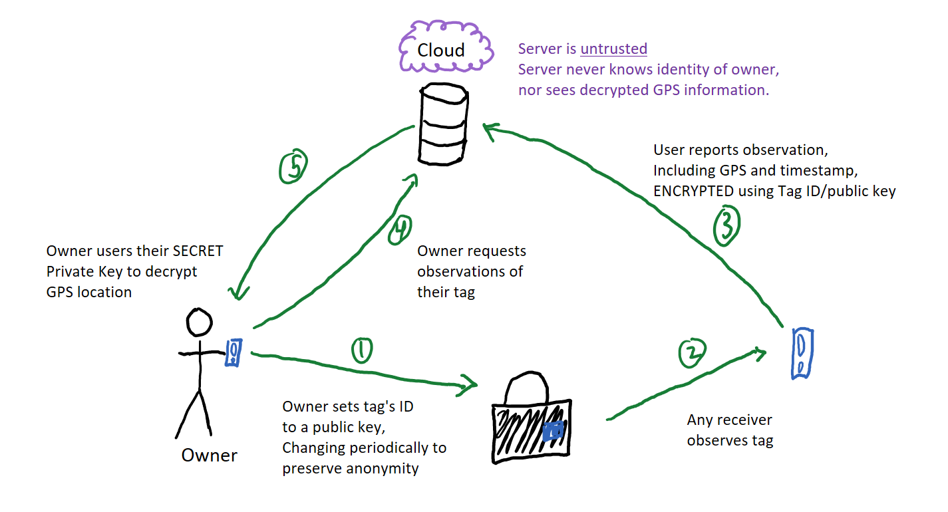

Beacons we plan to purchase (<http://bit.ly/2m9D71p>):